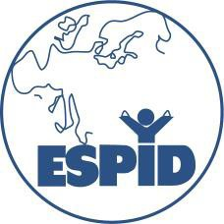
CURRENT AND FORMER ESPID HONORARY MEMBERS

- Prof. Vytautas Usonis, Lithuania (2025)

- Prof. Shai Ashkenazi, Israel (2024)

- Prof. Robert Cohen, France (2023)

- Dr Maria Theodoridou, Greece (2022)

- Prof. Claire-Anne Siegrist, Switzerland (2021)

- Sir Ronald de Groot, The Netherlands (2020)

- Dr. Steve Black, USA (2019)

- Prof. Milan Cizman, Slovenia (2019)

- Prof. Juhani Eskola, Finland (2019)

- Margareta Eriksson, Sweden (2018)

- Dr. Niels Valerius, Denmark (2018)

- Prof. Birger Trollfors, Sweden (2018)

- Dr. Josep Maria Corretger, Spain (2017)

- Prof. Anne Gershon, USA (2016)

- Prof. Ron Dagan, Israel (2015)

- Prof. James D. Cherry, USA (2012)

- Prof. Dimitris Kafetzis, Greece (2012)

- Prof. George McCracken, USA (2012)

- Prof. Urs B. Schaad, Switzerland (2011)

- Prof. Richard Moxon, United Kingdom (2010)

- Prof. Henry Shinefield, USA (2010)

- Dr. Francesc Asensi-Botet, Spain (2009)

- Prof. Ruggiero D’Elia, Italy (2009)

- Prof. Mieke Hoogkamp-Korstanje, The Netherlands (2008)

- Prof. Helmut Helwig, Germany (2004)

- Dr. John de Louvois, UK (2001)

- Prof. Max Just, Switzerland (1997)

- Prof. Walter Marget, Germany (1997)

- Prof. Constantinos Papadatos, Greece (1997)

- Prof. Claus Simon, Germany (1997)

